**DAILY ONLINE ACTIVITIES SUMMARY**

|  |  |  |  |  |  |  |  |  |
| --- | --- | --- | --- | --- | --- | --- | --- | --- |
| **Date:** | **14/06/2020** | | | | | **Name:** | **ASHISH GRACION MENEZES** | |
| **Sem & Sec** | **4&A** | | | | | **USN:** | **4AL18CS012** | |
| **Online Test Summary** | | | | | | | | |
| **Subject** | | **N/A** | | | | | | |
| **Max. Marks** | | **N/A** | | **Score** | | | **N/A** | |
| **Certification Course Summary** | | | | | | | | |
| **Course** | 1. **OPERATING SYSTEMS** | | | | | | | |
| **Certificate Provider** | | | 1. **MIT** 2. **NIET** | | **Duration** | | | **3 hours** |
| **Coding Challenges** | | | | | | | | |
| **Problem Statement1:Write a C program to remove specific characters of a string** | | | | | | | | |
| **Status:Executed** | | | | | | | | |
| **Uploaded the report in Github** | | | | | **YES** | | | |
| **If yes Repository name** | | | | | **https://github.com/ash7745/lockdown-coding** | | | |
| **Uploaded the report in slack** | | | | | **YES** | | | |

Online Test Details1: N/A

Certification Course Details: OPERATING SYSTEMS

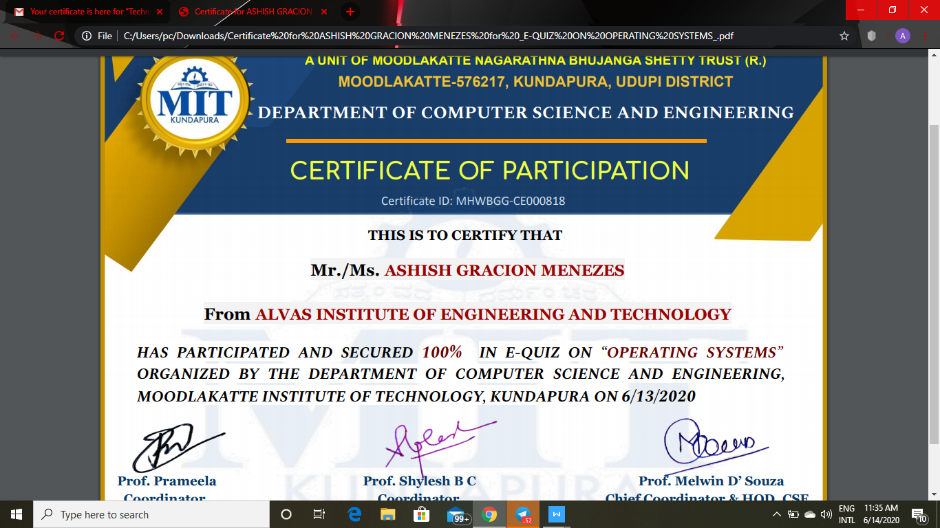

Certification Details:Technical Quiz

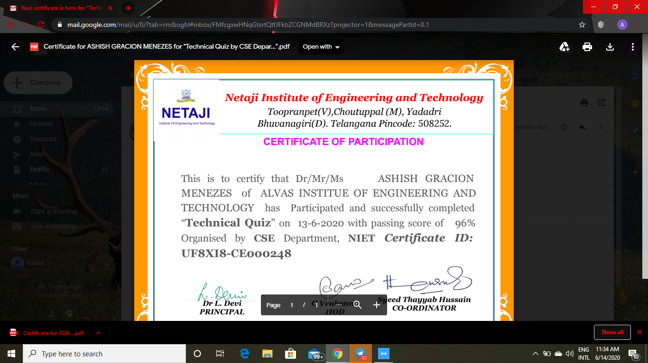

CODING DETAILS: Write a c program to remove specific characters in a string

